Cargo hold coatings – What can go wrong and what do we see?
The cargo holds (excluding the tank tops) of bulk carriers are typically coated with specialist abrasion resistant coatings to provide protection against corrosion, pitting and cargo contamination.
It is generally standard practice to leave the tank tops either in bare steel, or the newbuild thin film shop primer as any coating applied would get badly damaged by cargo loading and discharging operations. Therefore, ship builders normally build in a “corrosion allowance” or extra thickness of the tank top steel plates to allow for some general corrosion facilitated by the lack of protective coatings. For all areas other than the tank top a protective coating is applied.
However, these coatings are exposed to a very aggressive climate that can cause significant damages to the coatings, particularly if they have been poorly applied and/or maintained. These conditions include factors such as:
- High levels of mechanical damage.
- Exposure to chemically active cargos (coal, bauxite, coke, sulphur and petroleum coke).
- Exposure to high temperatures.
- Exposure to high humidity.
- Exposure to seawater (central cargo hold maybe in ballast on backhaul voyages).
- Exposure to salts.
In essence, cargo hold coatings are required to protect against impact, abrasion, humidity, heat, corrosion and prevent chemical and cathodic reactions.
Modes of coating failure:
The typical coating failures observed in cargo holds are as follows:
- Discolouration/staining – typically from carriage of coal or dirty cargos which are difficult to fully remove when cleaning after discharge.
- Scratches – to the hold coatings across the hopper plate, corrugated bulkhead and shell frames. Caused by mechanical impact and abrasion from cargo, grabs, bobcats and excavators etc.
- Corrosion – due to moisture in cargos or from seawater.
- Blistering – caused by acidic cargos, for example from the formation of sulphuric acid due to moisture in coal.
- Delamination/detachment – due to surface contamination, for example dry spray from application to the frames and shell plates, or dust/blasting grit falling onto the hopper plating and not removed prior to application of the subsequent coating.
- Loss of adhesion – due to insufficient surface preparation or lack of surface tolerance.
- Softness – due to high dry film thickness (DFT) from overapplication of the hold coatings.
Common reasons for cargo hold coating failures:
Safinah Group have extensive experience investigating cargo hold coating failures and the typical examples include:
- Failure due to poor workmanship in the shipyard.
- Cosmetic coats applied at newbuilding which lead to detachment and subsequent cargo contamination (photos 1 and 2).
- Solvent retention under restricted ventilation (when the cargo hatch is closed too early after application) or not following recommended minimum overcoating intervals.
- Blasting grit contamination (photo 3).
- Overapplication of the coating (photo 4) which leads to cargo gauging damages in service.
- Use of an inappropriate cargo hold coating.
- Poor surface preparation prior to application.

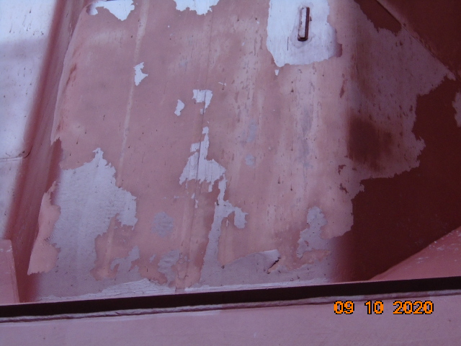  Photo 1: Delamination of Newbuild cosmetic coat | 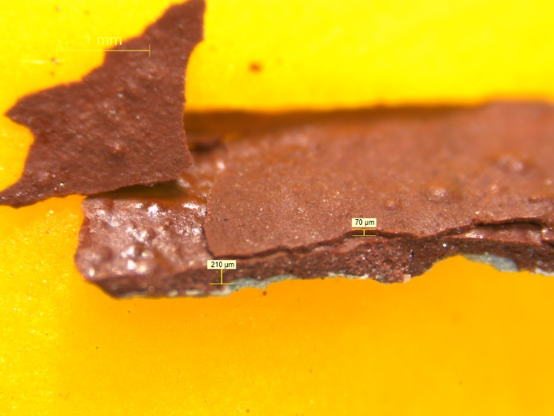  Photo 2: Paint flake samples under optical microscopy – cosmetic coat delamination
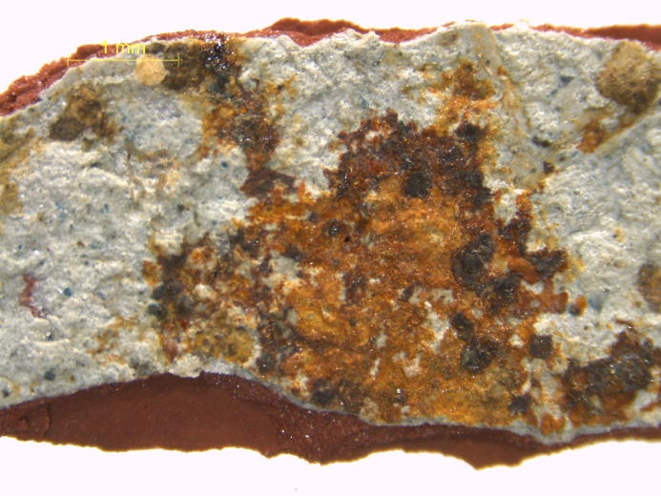  Photo 3: Blasting grit contamination and corrosion on the under side of paint flake samples | 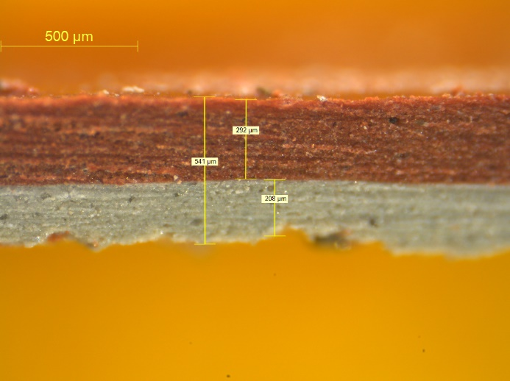  Photo 4: Overapplication. Scheme DFT is 2 x 125µm (total 250µm). However actual DFT applied is approximetly 540µm.

- Failure due to commercial operations:
- Early loading of hard angular cargo, i.e. not respecting time to first cargo loading (photos 5 and 6).
- Poor application / insufficient thickness of lime wash when carrying sulphur cargos (photo 7).
- Delamination due to poor cleaning after cargo discharge, prior to onboard coating spot repairs (photo 8).
- Spinning disc distribution of coke breeze cargo during loading causing pinpoint coating damages and extensive rust staining across the bulkheads (photos 9 & 10).

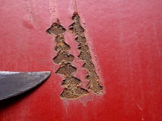  Photo 5: Gouging damage from hard angular cargos | 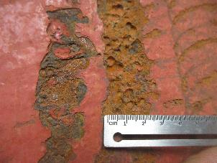  Photo 6: Gouging damages from hard angular cargo and subsequent corrosion and pitting
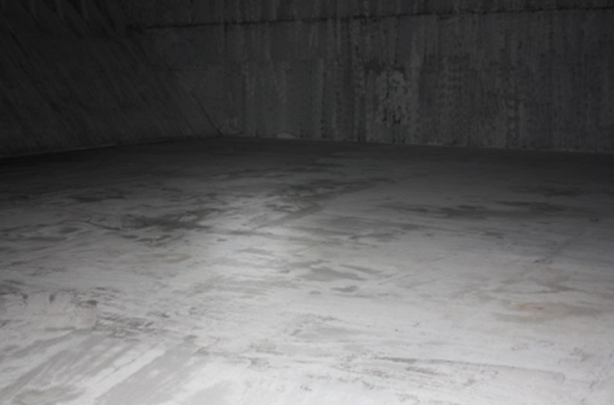  Photo 7: Uneven coverage of lime wash | 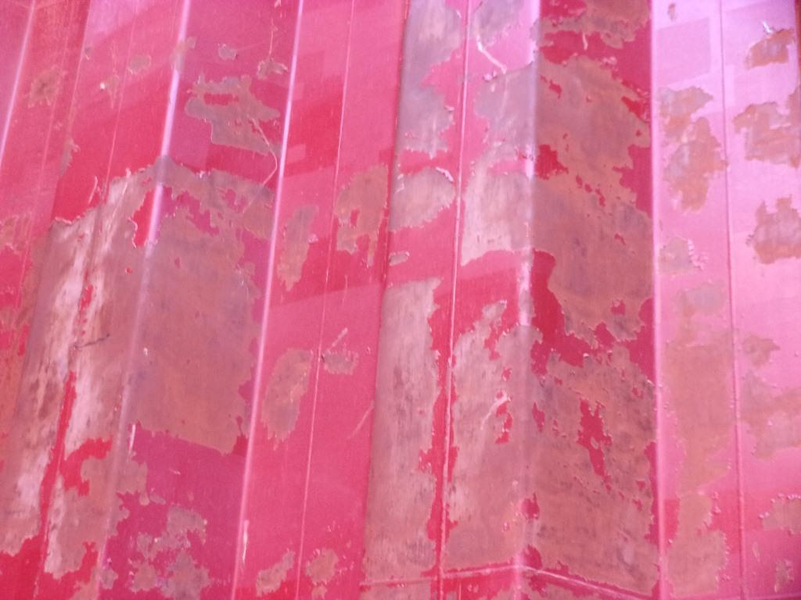  Photo 8: Peeling and delamination due to poor cleaning prior to onboard spot repairs
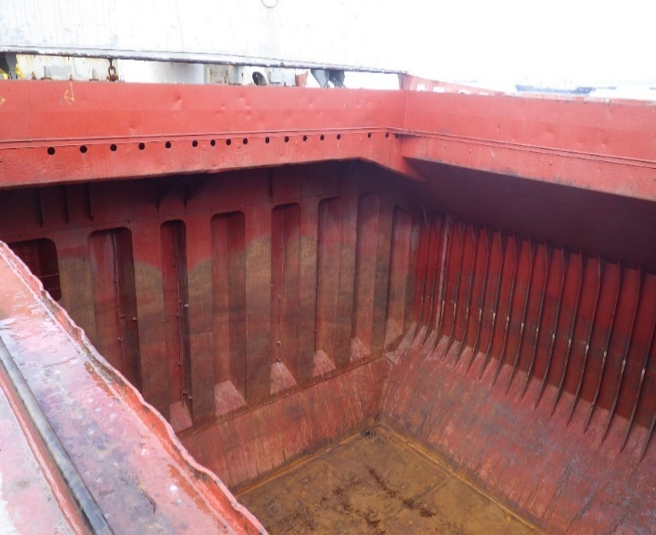  Photo 9: Rust staining across the bulkheads |   Photo 10: Close up of pinpint damages

The question we often get asked is “will a cargo hold coating protect the cargo hold against all damages and corrosion?”
Unfortunately, the answer is no, however a high quality cargo hold coating, correctly applied and maintained, can delay the onset of significant corrosion in the cargo hold and subsequently extend the time before costly major refurbishment becomes a requirement.
For no obligation advice on any aspect of coatings or corrosion, contact our insurance and litigation experts on +44 1670 519 900 or email the team at insurance@safinah-group.com

